1. 5 = I * (1x10^-6) I = 500,000
2. 3.3 = 10*R R= 330 Ohms
3. 2.9 = 10*R R = 290 Ohms
4. Q2 uses a 330R resistor, Q3 uses 290R resistor

|  |  |  |
| --- | --- | --- |
| Input 1 | Input 2 | Output 3 |
| 0 | 0 | 0 |
| 0 | 1 | 0 |
| 1 | 0 | 0 |
| 1 | 1 | 1 |

6. With both wires are floating inputs the LED remains on.

7. 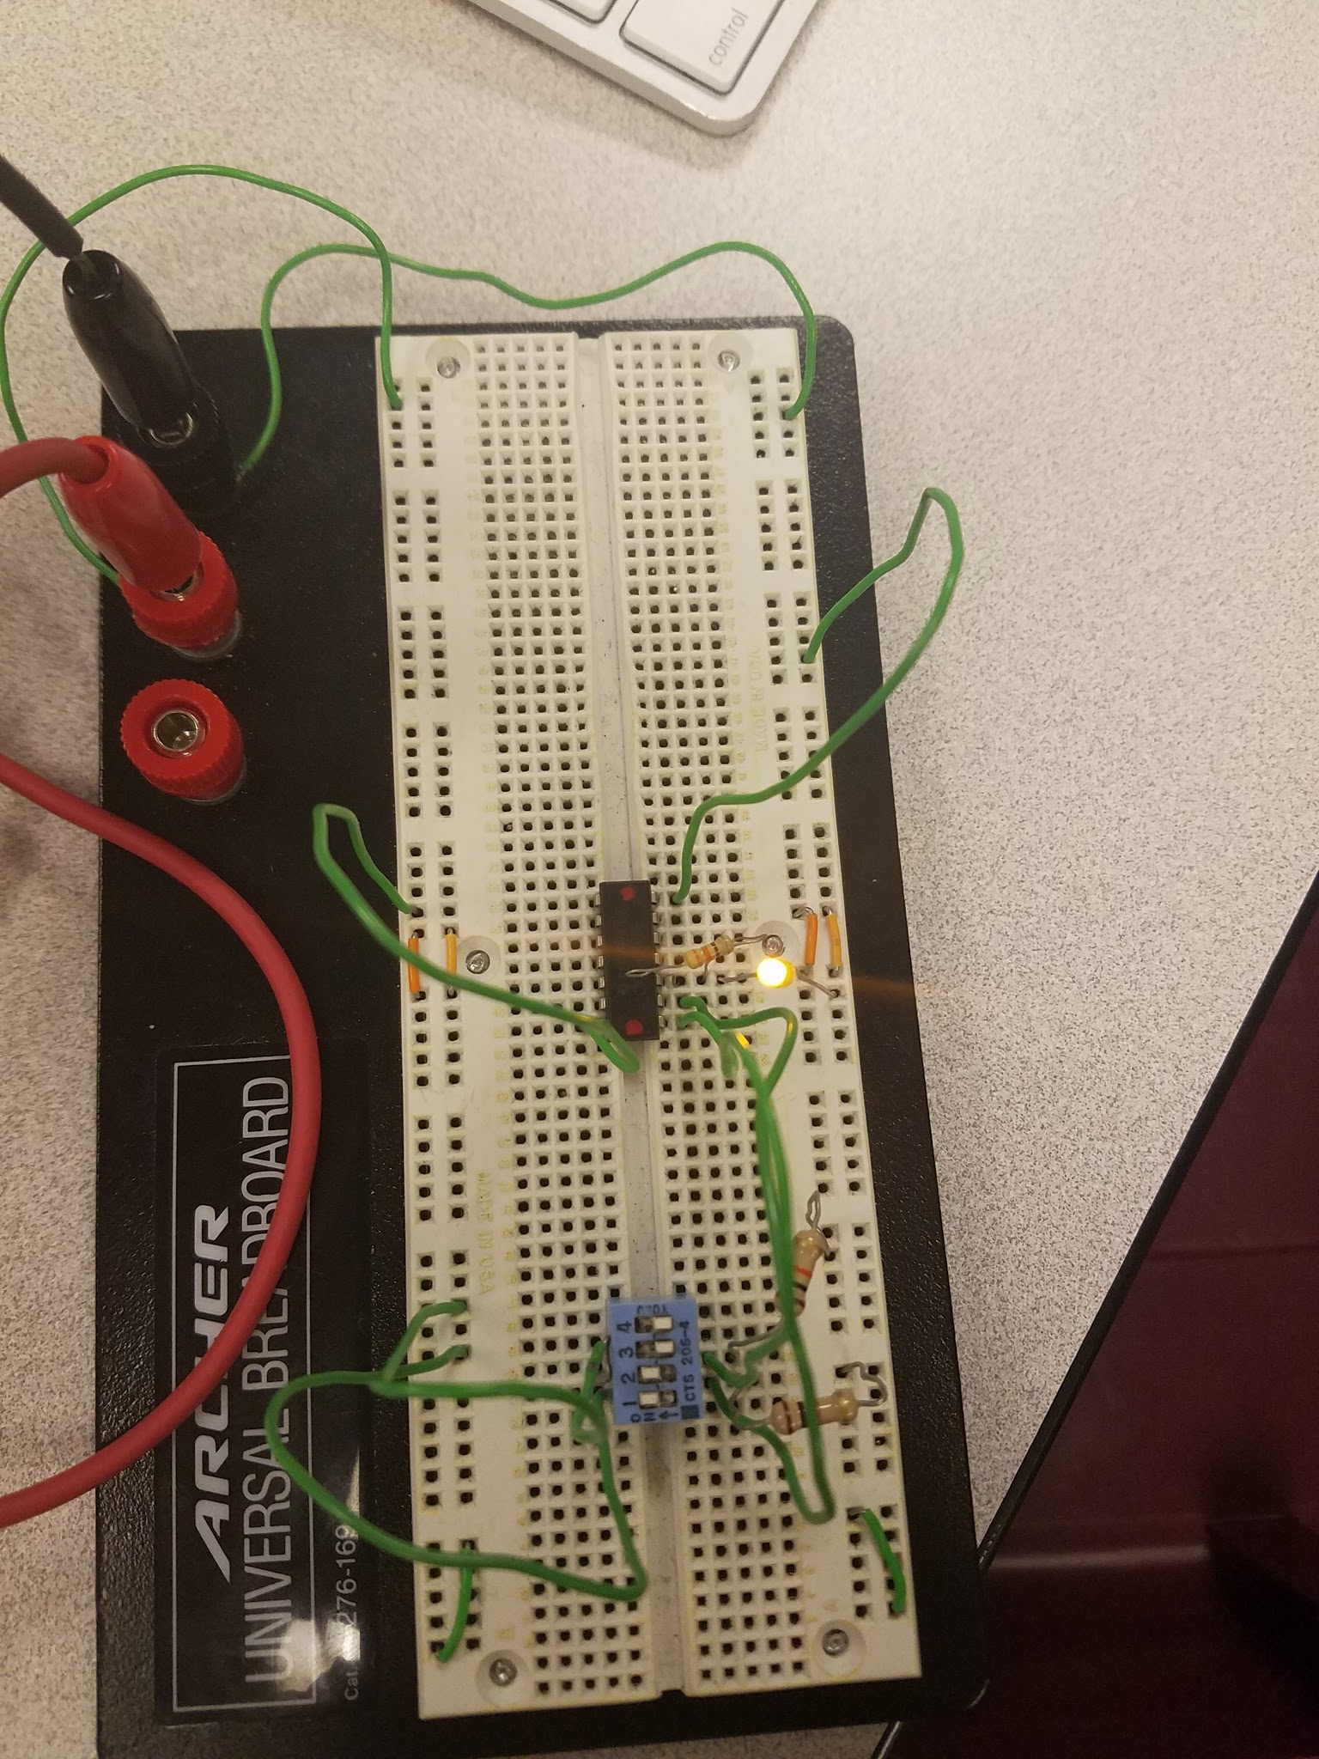

8.

|  |  |  |
| --- | --- | --- |
| Input 1 | Input 2 | Output 3 |
| 0 | 0 | 0 |
| 0 | 1 | 1 |
| 1 | 0 | 1 |
| 1 | 1 | 0 |

We were given chip ‘C’ as our random chip. Based on the truth table we concluded that chip ‘C’ is an XOR chip.

9.

|  |  |  |  |
| --- | --- | --- | --- |
| Input 1 | Input 2 | Output X | Output Y |
| 0 | 0 | 0 | 0 |
| 0 | 1 | 1 | 0 |
| 1 | 0 | 1 | 0 |
| 1 | 1 | 1 | 1 |

10. This circuit implements a two bit adder.

11. 